Ghana2012/13 (GLSS6) - see notes below

|  |  |  |  |  |  |  |
| --- | --- | --- | --- | --- | --- | --- |
| % Households | Subsistence | Pre-Commercial | Commercial specialized | Transition | Commercial Diversified | Total |
| 8.1 | 14.5 | 22.6 | 38.9 | 15.9 | 100 |
| Distribution of each HH type by development domain (columns add to 100%) - **GAEZ** | | | | | | |
| LL (Ag., Mkt) | 3.5 | 3 | 2.7 | 2.6 | 2 | 2.9 |
| LH | 1 | 1.6 | 0.6 | 8.6 | 3.6 | 4.3 |
| HL | 79.9 | 77.5 | 79.5 | 63.1 | 69.8 | 71.2 |
| HH | 15.5 | 17.9 | 17.3 | 25.7 | 24.6 | 21.6 |
| Total | 100 | 100 | 100 | 100 | 100 | 100 |
| Distribution of HH types across development domains - **GAEZ** | | | | | | |
| LL | 0.3 | 0.4 | 0.6 | 1 | 0.3 | 2.7 |
| LH | 0.1 | 0.2 | 0.1 | 3.3 | 0.6 | 4.4 |
| HL | 6.5 | 11.2 | 18 | 24.6 | 11.1 | 71.3 |
| HH | 1.3 | 2.6 | 3.9 | 10 | 3.9 | 21.6 |
| Total | 8.1 | 14.5 | 22.6 | 38.9 | 15.9 | 100 |
| Distribution of each HH type by development domain (columns add to 100%) - **GLUES** | | | | | | |
| LL (Ag., Mkt) | 21.3 | 23.4 | 33.8 | 21.6 | 30.4 | 25.9 |
| LH | 13.3 | 13.6 | 15.5 | 25.9 | 24.7 | 20.3 |
| HL | 55.7 | 48.3 | 38.8 | 35.1 | 30.6 | 39 |
| HH | 9.7 | 14.6 | 11.9 | 17.4 | 14.2 | 14.8 |
| Total | 100 | 100 | 100 | 100 | 100 | 100 |
| Distribution of HH types across development domains - **GLUES** | | | | | | |
| LL | 1.7 | 3.4 | 7.6 | 8.4 | 4.8 | 26 |
| LH | 1.1 | 2 | 3.5 | 10.1 | 3.9 | 20.6 |
| HL | 4.5 | 7 | 8.8 | 13.6 | 4.9 | 38.8 |
| HH | 0.8 | 2.1 | 2.7 | 6.8 | 2.3 | 14.6 |
| Total | 8.1 | 14.5 | 22.6 | 38.9 | 15.9 | 100 |
| Household means | | | | | | |
| % NFI | 2.2 | 3.3 | 4 | 92.5 | 82.3 | 42.9 |
| % Cash sales | 0.3 | 29.6 | 76.6 | 7.7 | 78.6 | 43.6 |
| Median income | 330.2 | 934.6 | 1,511.40 | 8,175.30 | 11,445.20 | 2,149.90 |
| Age head | 49.6 | 47 | 47.4 | 48.9 | 48.1 | 48.2 |
| % Female headed | 30.1 | 20.9 | 20.7 | 33.6 | 26.2 | 27.1 |
| Household size | 4.2 | 4.8 | 4.3 | 4.5 | 4.4 | 4.5 |
| Adult workers | 2.1 | 2.3 | 2.1 | 2.3 | 2.2 | 2.2 |
| Owned farm size | 0.8 | 1.1 | 1.3 | 1 | 1.1 | 1.1 |
| Cultivated area | 1 | 1.5 | 1.7 | 1.2 | 1.5 | 1.4 |
| Education head | 3.1 | 3.6 | 4.1 | 5.6 | 5.8 | 4.5 |
| Highest education | 5.3 | 5.5 | 5.8 | 7.3 | 7.3 | 6.3 |
| Cell phone | 22.8 | 20.4 | 18.2 | 13 | 14.6 | 17.5 |
| Electricity | 29.3 | 29.8 | 34.3 | 65.9 | 59.5 | 42.2 |
| Distance to road | 1.6 | 1.2 | 0.9 | 0.3 | 0.3 | 0.7 |
| Seeds | 9.3 | 17.5 | 15.7 | 15.4 | 18.9 | 16.4 |
| Fertilizer (inorg.) | 29.1 | 35.5 | 34.8 | 20.4 | 25.3 | 27.9 |
| Hired labor | 30 | 44.3 | 48.5 | 43 | 50.8 | 44 |

2 versions of the quadrant classification are included (GAEZ and GLUES). They correspond to the following maps:

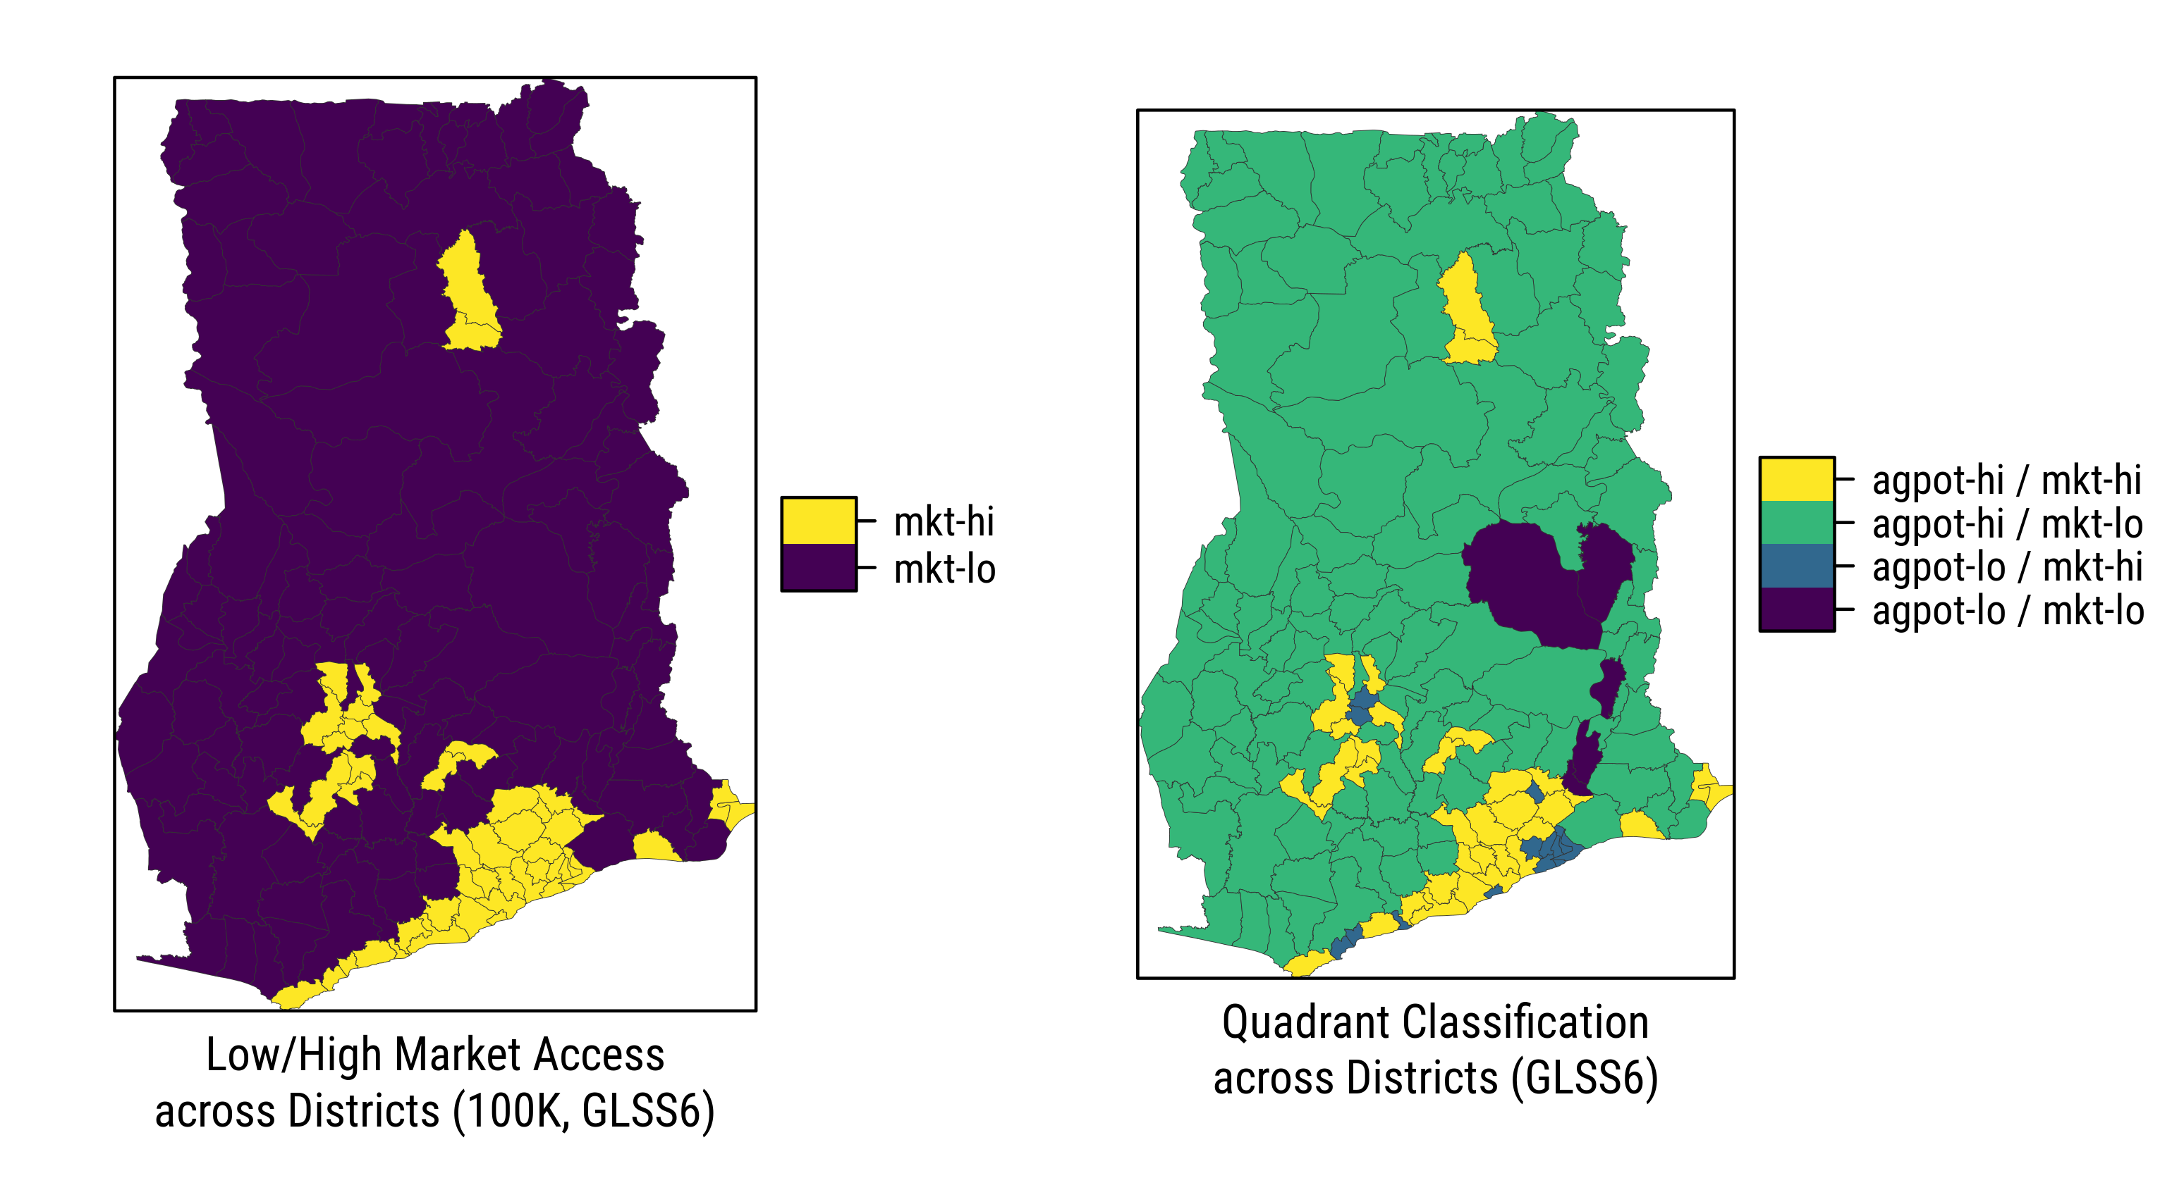

Fig. 4.5: Quadrant Classification across Districts, Ghana 2012/13. Source: authors/FAO/GAEZ.

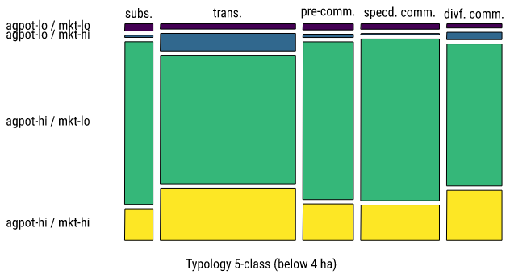

Fig. 4.11: Est. Proportions of Farm Holdings across Combined Categories (farms below 4 ha). Source: authors/FAO/GAEZ.

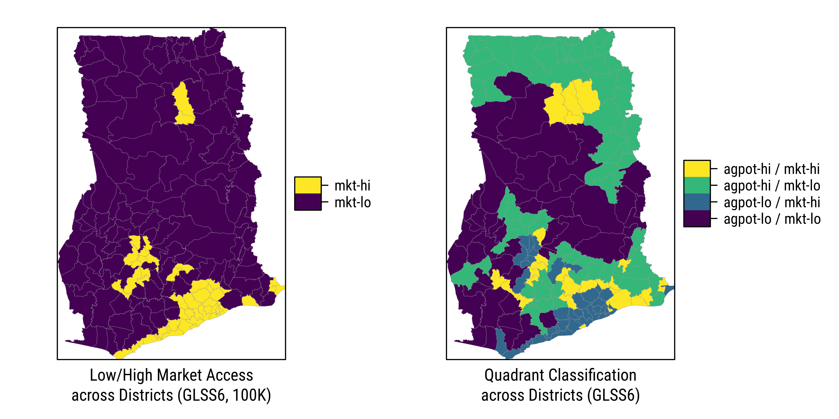

Fig. 4.16: Quadrant Classification across Districts, Ghana 2012/13. Source: authors/GLUES.

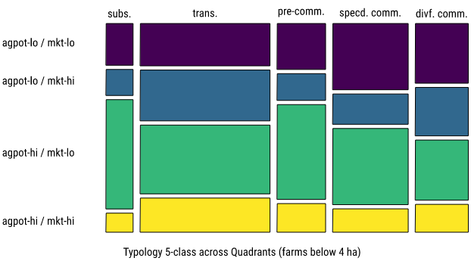

Fig. 4.18: Est. Proportions of Farm Holdings across Farm Types and Quadrants (farms below 4 ha, GLUES crop suitability). Source: authors/GLUES.